School of Conflict Management, Cross Cultural Communication, Leadership, Mediation and Human Resources Management

Application

Spring Academy: 10 - 19 March, 2025

Antalya, Türkiye

- Early Bird Application Deadline: 25 November, 2024
- Late Application Deadline: 12 February, 2025

Photo

Personal Details

1. Name:
2. Surname:
3. Nationality:
4. Date of birth (DD.MM.YY):
5. Passport number:
6. Date of expire (DD.MM.YY):
7. Post address: (country, city, region, district, house, street, apart., zip code and etc.)
8. Office & Personal E-mail:
9. Cell / WhatsApp number (Please send invitation):
10. LinkedIn, Skype & Facebook addresses (Please send invitation):
11. Name of your Organization & Your Position (If available):
12. Reference Person (Name, surname, email, web page, tel. and etc.):
13. Relevant Embassy Email:
IPD will send invitation letter to relevant embassy email address if you need
14. How did you hear about Antalya Spring Academy?
15. How you will cover your participation fee amount?
- Myself Yes
- My work or study place Yes
- Family member Yes
- Friend or Colleague Yes
- Other Sources (Please specify the financial aid source) Yes

Education

Name & Email of University | Graduation Year | Degree Obtained

Work Experience

Date:  mm/yyyy - mm/yyyy | Country | Name & Email of Company/Organization | Title of Position

Motivation for Participation (Not more than 500 words)

Special Needs

Do you have any special needs or requirements that the organizers should take into account during the Antalya Spring Academy (e.g. dietary, vegetarian, disability, etc.)? Yes No If Yes Please specify

Please choose your payment options

A) Winter Academy Participation Fee

- Early Bird Application Fee with Single Room: 1850EUR Yes
- Early Bird Application Fee with Double Room: 1500EUR Yes
- Early Bird Application Fee without Accommodation & Breakfast: 1000EUR Yes

- Late Application Fee with Single Room: 2450EUR Yes
- Late Application Fee with Double Room: 2100EUR Yes
- Late Application Fee without Accommodation & Breakfast: 1400EUR Yes

B) Additional Expenses

- Additional night stay in Single room includes breakfasts and local city transport ticket: Yes
Please specify number of additional nights with your desired dates ___________

- Additional night stay in Double room includes breakfasts and local city transport ticket: Yes
- Welcome meeting in Airport and transfer to hotel: 100EUR per person Yes

- I am Alumni of IPD programs (10% discount) Yes
- I am student (10% discount) Yes
- I am Small NGO representative (10% discount) Yes
- I am paying together with group of participants (More than 2 person for 10% discount) Yes
- I am ProPeace Member (For 10% discount please visit www.ipdinstitute.ch) Yes

Cancellation Rules & Procedure

Below stated high cancellation prices stated because of to prevent the mass application submission of non-serious people and prevent the financial risks of accommodation expenses.
Please note that after submission of the application, any participation cancellation until 5 February, 2025 the charge will be 550EUR (not including bank transfer and exchange rates costs) for the participants of Spring Academy from the paid participation fee for the administrative charges.
For participation cancellation between 5 - 28 February, 2025 the charge will be 1200EUR (not including bank transfer and exchange rates costs) for the participants of Spring Academy from the paid participation fee for the administrative charges.
For participation cancellation after 28 February, 2025, there will be no refund on the paid participation fee.
Participant responsible to inform IPD directly by email or post about his/her participation cancellation.

Bank Account Information to Transfer the Participation Fee

Beneficiary`s Name: Institute for Peace and Dialogue (IPD)
Bank Name: PostFinance Ltd
Bank Address: Mingerstrasse 20, 3030 Bern, Switzerland
Account number: 91-577724-2 EUR
IBAN: CH 27 0900 0000 9157 7724 2
SWIFT code: POFICHBEXXX

Declaration of the Applicant

By submitting this Application Form, I confirm that all the information given in this form is correct, true and complete. I also confirm that I agree to the following conditions of participation:

Yes I will actively join each of the activities during the training program.
Yes I understand that the organiser reserves the right to exclude the participant from the course in case information given in the form proves to be incorrect or because of misconduct at the training program.
Yes I confirm that I don’t have any refusal and grant IPD with irrevocable right using of my photos in IPD promotional works, materials and website for irrespective of time and place
Yes I will respect to other nations and race during the training program
Yes I confirm the participation cancellation rules & conditions

Name & Surname:

Date/Venue:
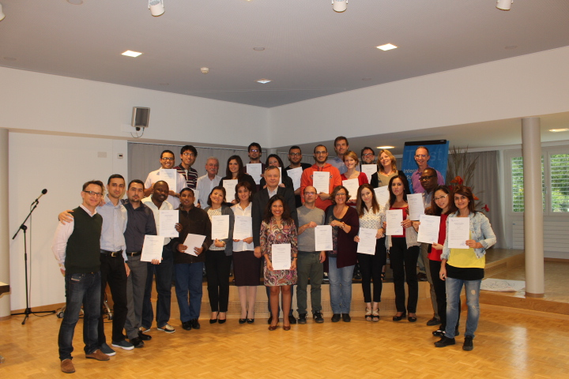

Contact person for any questions:

Mr. Fakhrinur Huseynli
Director
Institute for Peace and Dialogue (IPD)
Address: Ryffstrasse 23,
4056 Basel, Switzerland
E: fhuseynli@ipdinstitute.ch
www.ipdinstitute.ch
Cell/WhatsApp: +41 76 431 61 70
S: fakhrinur.huseynli
LinkedIn Profile: https://www.linkedin.com/in/fakhrinur-huseynli-574776223/

Follow us on Facebook
https://www.facebook.com/Institute-for-Peace-Dialogue-105141534911793/?ref=page_internal

If you have any problem to contact with us via your office email, then please try to write us via online contact form or via your personal email or via LinkedIn or via Skype and inform your
IT Department about the existed technical problem.

We are looking forward to seeing you in our Antalya Spring Academy 2025

IPD Training Programs: Theory - Practice - Research - Exchange - Networking - Contribute

